All of our templates are packed with:
- Extensions - These are modules/plugins/component to use on this template.
- Template - This is only the template install file
- Quickstart - This is your main quickstart package, it will help you to rebuild demo.
- Documentation
If this template is not downloaded directly from amazing-templates.com. Please, go to our website and download full template pakage.
This documentation file helps you build your site manualy

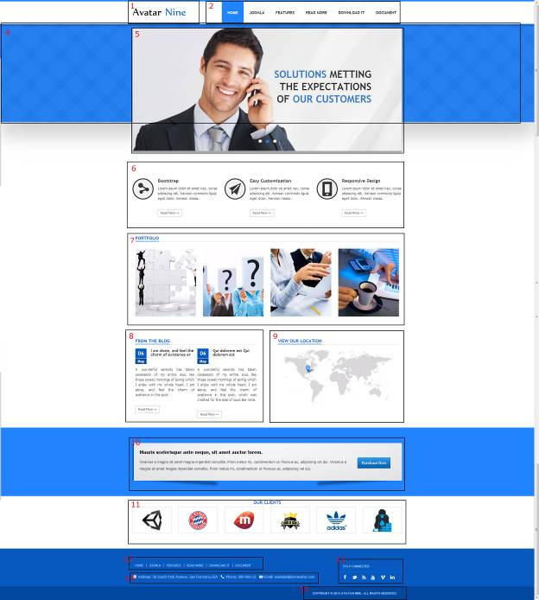
1.
Module Type: Custom HTML
Module Name: Logo (hide title)
Module Class Suffix: no-padding-marging avatar-template-logo
Position: Top-left
HTML source code:
<p><a href="Your Link Site "><span style="color: #000;">Your</span> Site Name</a></p>

2.
Module Type: Menu
Module Name: Main Menu
Module class suffix: _menu no-padding-marging
Menu class suffix: avatar-main-menu
Alternative layout: Responsive
Position: Top-right

4.
Module Type: Custom HTML
Module Name: SOLUTIONS METTING THE EXPECTATIONS OF OUR CUSTOMERS
Module Class Suffix: avatar-separate-bg no-padding-marging
Position: content-top

HTML source code:

5.
Module Type: Avatar Articles Nivo
Module Name: Banner Tool home 1
Module Class Suffix: avatar-caption no-padding-margin-side
Module Postion: Content-top

Go to Content Manager.
Creat New Category.
Create articles in category just created.
In a newly created articles, Select intro image and written content slide.
Then go to the Banner Tool Home Manager.
Select the category for slidershow.

6.
Module Type: Avatar Template Showcase
Module Name: Features Home News Style 4
Module class suffix: no-padding-margin-side
Module showcase: features_3
Position: full-3

DATA
Go to Content Manager.
Creat "Features News Style" Category.
Create articles in category just created.
In a newly created articles, and add image icon like demo.
Then go to the Features Home News Style 4 Manager.
Select the category for display.

7.
Module type: Avatar Template Showcase
Module name: PORTFOLIO
Module class suffix: no-padding-margin-side avatar-module-7
Moudle SHowcase: portfolio_2
Position: full-3

DATA
Go to Content Manager.
Creat WORKS Category.
Create work articles in category just created.
In a newly created articles, Select intro image and writte content.
Then go to the PORTFOLIO Manager.
Select the category for display.

8.
Module Type: Avatar Template Showcase
Module Name: FROM THE BLOG
Module class suffix: no-padding-marging avatar-module-7
Module showcase: news_1
Position: promo-bottom-left

DATA
Go to Content Manager.
Creat "Extensions" Category.
Create articles in category just created.
In a newly created articles, write description.
Then go to the FROM THE BLOG Manager.
Select the category for display.

9.
Module Type: Custom HTML
Module Name: VIEW OUR LOCATION
Module class suffix: no-padding-marging avatar-module-7
Position: promo-bottom-right
HTML source code:
<p><img src="images/sampledata/avatar_nine/our-location.png" alt="" /></p>

10.
Module Type: Custom HTML
Module Name: Slogan bottom - home new style 4
Module class suffix: no-padding-margin-side
Position: full-4
HTML source code:
<p style="float: right; margin: 30px 20px;"><a class="btn" href="#" target="_blank"><span style="font-size: 13px; line-height: 24px;">Purchase Now</span></a></p>
<p><strong style="line-height: 24px; font-size: 16px; color: black;">Mauris scelerisque ante neque, sit amet auctor lorem. </strong></p>
<p><span style="line-height: 24px; font-size: 13px;">Vivamus a magna sit amet magna imperdiet convallis. Proin metus mi, condimentum ut rhoncus ac, adipiscing vel dui. </span><span style="font-size: 13px; line-height: 24px;">Vivamus a magna sit amet magna imperdiet convallis. Proin metus mi, condimentum ut rhoncus ac, adipiscing vel dui.</span><span style="font-size: 13px; line-height: 24px;"><br /></span></p>

11.
Module Type: Avatar Template Showcase
Module Name: OUR CLIENTS
Module class suffix: no-padding-marging avatar-heading-center
Module showcase: clients
Position: full-6

DATA
Go to Content Manager.
Creat CLIENTS Category.
Create articles in category just created.
In a newly created articles, and written content slide.
Then go to the OUR CLIENTS Manager.
Select the category for display.

12.
Module Type: Menu
Module Name: Footer Menu
Module class suffix: no-padding-margin-side
Menu class suffix: avatar-footer-nav
Alternative layout: Responsive
Position: Footer-Left

13.
Module Type: Custom HTML
Module Name: Address
Module Class Suffix: avatar-module-border-top avatar-footer-address no-padding-marging
Position: Footer -left

HTML source code:
<ul style="display: table;">
<li class="avatar-address"><span style="line-height: 1.3em;">Address: Your Address</span></li>
<li class="avatar-phone"><span style="line-height: 1.3em;">Phone: Your Phone Number</span></li>
<li class="avatar-email"><span style="line-height: 1.3em;">Email: Your email</span></li>
</ul>

14.
Module Type: Custom HTML
Module Name: STAY CONNECTED
Module Class Suffix: no-padding-margin-side social-heading
Position: Footer -right
HTML source code:
<div class="avatar-footer-social avatar-module-border-top">
<a class="facebook" href="Your Facebook Link"> </a>
<a class="twitter" href="Your Twitter Link"> </a>
<a class="feed" href="Your Feed Link"> </a>
<a class="youtube" href="Your Youtube Link"> </a>
<a class="vimeo" href="Your Vimeo Link"> </a>
<a class="linkedin" href="Your Linkedin Link"> </a>
</div>

15.
Module Type: Custom HTML
Module Name: copyright
Module Class Suffix: avatar-copyright
Position: Footer

HTML source code:
<p><a href="www.joomavatar.com">Copyright © 2013 Avatar Nine. All Rights Reserved.</a></p>

